**Delyar Tabatabai**

[**tabatase@oregonstate.edu**](mailto:tabatase@oregonstate.edu)

**Project 6 - shaders**

**Best Image:**

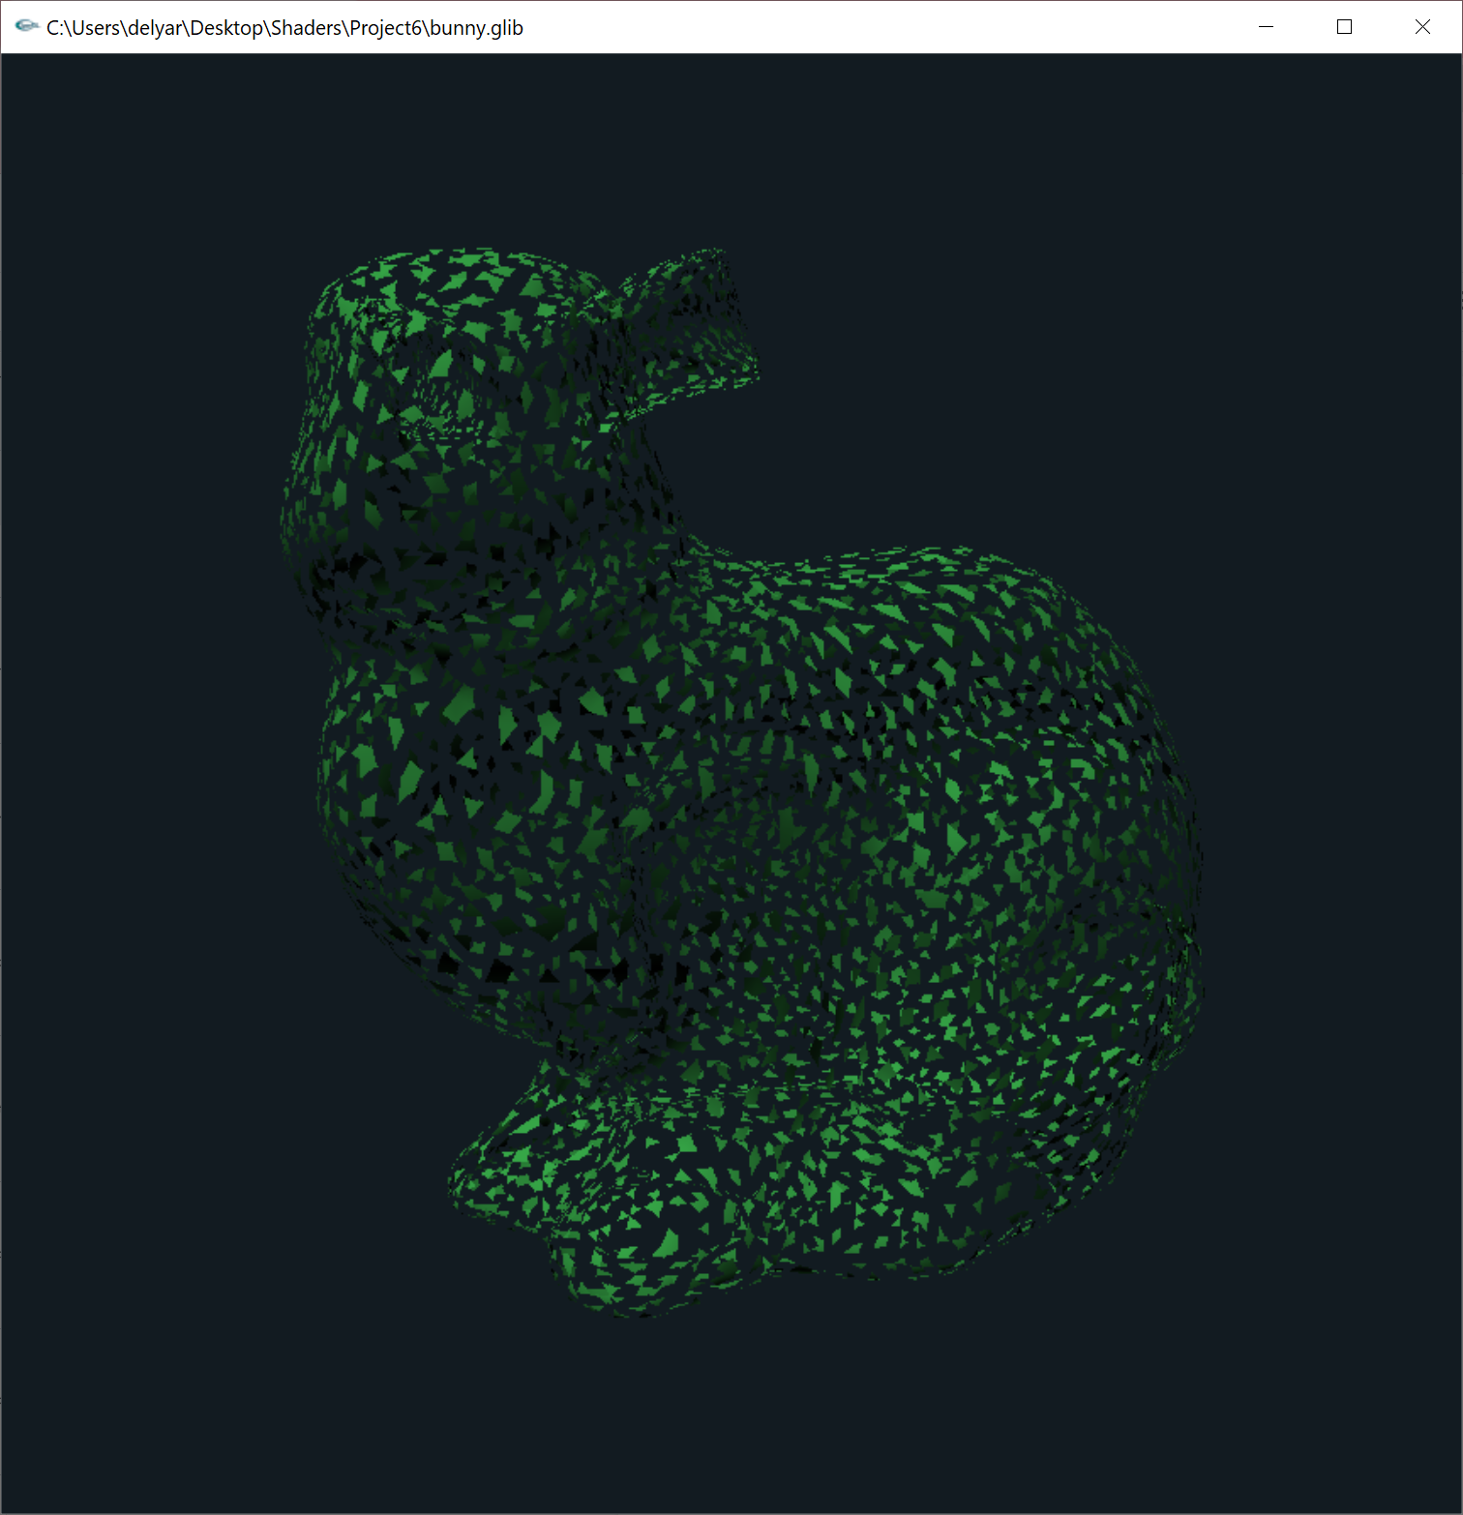

**Images:**

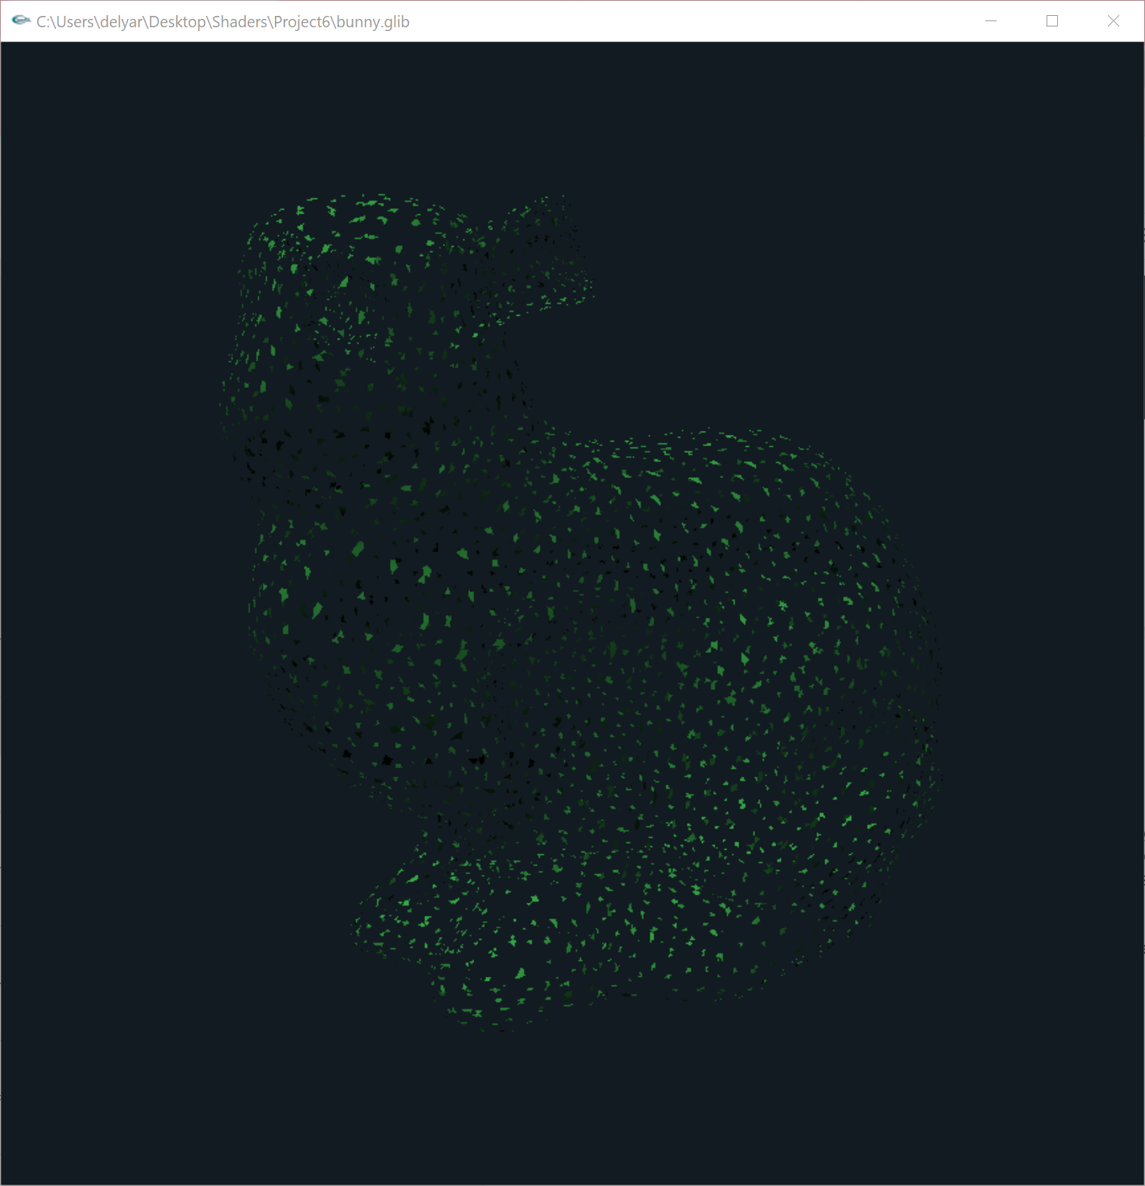

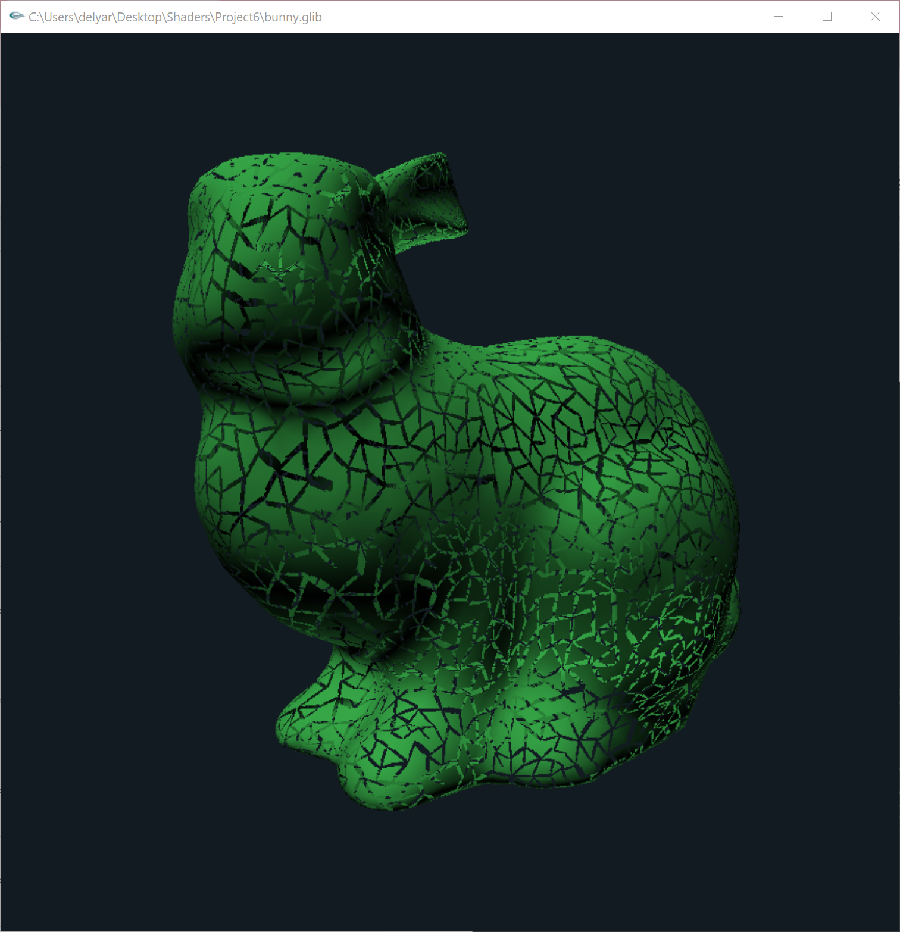

**Description**:

In this project, I am trying to make a tessellation on the bunny with the geometry shader.

The geometry shader takes a triangles as input and performs tessellation on it. The input triangles consists of a set of triangles with vertex positions and normals.

I first calculate the parameters for the current layer of tessellation, then in the for loop I am generating new vertices along the edges of the input triangles.

At the end, we close the tessellated triangle strip and prepare for the next layer.

**Video Link:**[**https://media.oregonstate.edu/media/t/1_s85fdt9m**](https://media.oregonstate.edu/media/t/1_s85fdt9m)